Determination of Absolute Zero on the Celsius Scale
Troy University Chemistry Faculty
Licensed under a Creative Commons Attribution-ShareAlike 4.0 International License.

Objectives
To give a feel for how gases behave when heated.

Introduction

The plot above shows how the value of absolute zero is determined experimentally. The volume and temperature of a fixed amount of gas at constant pressure are measured at two different temperatures, giving a pair of points: (T_{low}, V_{low}) and (T_{high}, V_{high}). These two points of data are plotted. As temperature is lowered, the volume gets smaller. It looks like the volume would become zero if the temperature were made low enough. To determine at what temperature the volume would appear to go to zero, a line is drawn connecting the two data points, then the line is extended such that the volume gets less and less as the temperature gets lower and lower. Eventually, the line reaches a point where the volume would be zero. This occurs where the line touches the x-axis; the point is called the x-intercept (in contrast the y-intercept is where the line crosses the y-axis). This x-intercept corresponds to a particular temperature, which is called absolute zero. Getting colder than absolute zero makes no sense, because volume cannot be less than zero.
Extending the line in the plot beyond the range of the data points is called extrapolation. This is considered dangerous because a system may behave differently outside the range for which data exists. For example, gas is being treated as if it is an ideal gas, for which the gas particles have a volume of zero. Real gases have real volumes; as a real gas is cooled, it turns into a liquid, then a solid, both of which have non-zero volumes. In spite of that, this method of determining absolute zero works reasonably well, because the volume of the gas particles is small compared to the volume of the gas at higher temperatures.

Procedure:
- Prepare a boiling water bath. Add about 400 mL of tap water to a 500 mL beaker. Heat the water to boiling on a hot plate.
To heat the water quickly, set the hot plate temperature to high until the water boils, then turn it down to, say, 200 °C to keep it boiling.
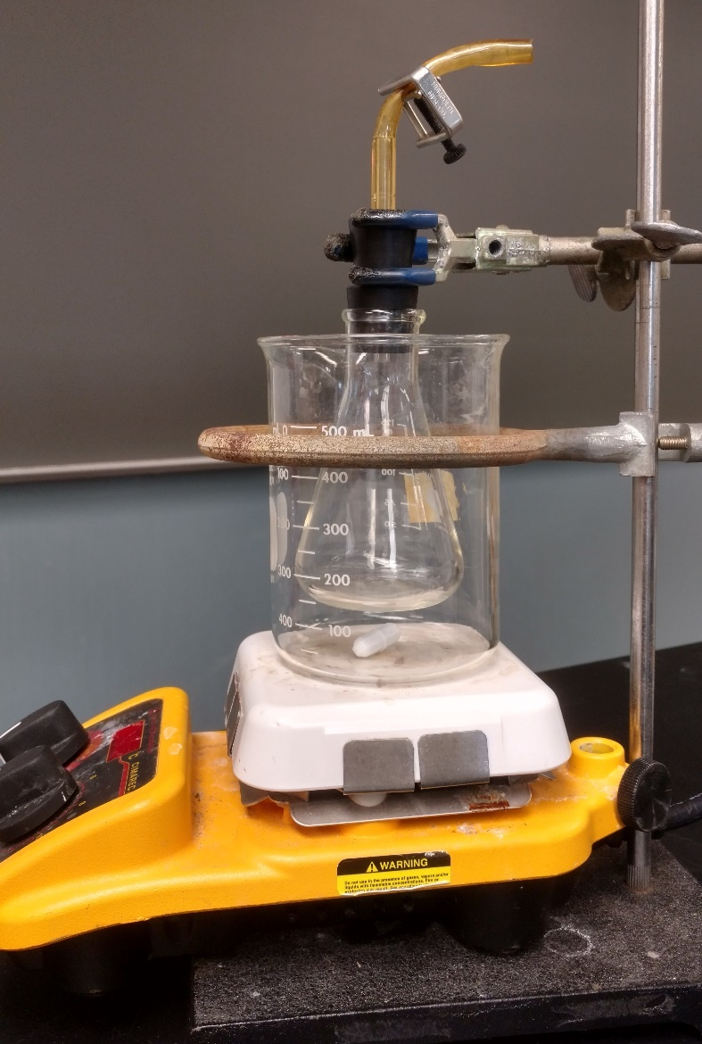
- Assemble and weigh the gas flask. Two one-hole stoppers on a glass tube with a short piece of tubing attached to the top should be provided. If not already present, attach a pinch clamp to the tubing, but don’t tightened the clamp, yet. This will be called the “stopper assembly”. Firmly attach the stopper assembly to an absolutely dry 125 mL Erlenmeyer flask; this will be the “flask assembly”. Weigh the flask assembly to at least the nearest 0.1 g. Record this data in the data sheet.
If the Erlenmeyer flask contains even a drop of water, the lab will not work. The volume of gas in the flask is to be measured in the boiling water bath and at room temperature. If the gas is water, instead of air, the gas will condense to liquid at room temperature, instead of staying gaseous.

- Heat the gas to the temperature of the boiling water bath. With the pinch clamp open, place the flask assembly in the boiling water bath such that the water level is even with the bottom of the bottom stopper. The flask should be at least 1 cm above the bottom of the beaker (if it touches the bottom, the gas may get hotter than the water bath) and does not touch the side of the beaker. If necessary, adjust the water level in the beaker by adding or removing water. Turn up the heat until the water boils again, and continue boiling for 5 min. Measure the temperature of the boiling water. This temperature is t_{high}. Record this data in the data sheet.
- Prepare a cold water bath. Fill a plastic pan with around 4 inches of cold tap water.
- Cool the gas to the temperature of the cold water bath. With the flask still in the boiling water bath, firmly close the pinch clamp. Using the clamp as the handle, remove the flask assembly from the beaker and completely submerge it in the pan. Make sure everything is kept below the water surface to prevent air from entering the flask.
- Let water into the cool flask. With everything completely submerged, carefully open the pinch clamp on the plastic tubing so that some water will be sucked into the flask by the contraction of the air. (The pinch clamp stays open until step 8.) If no water is sucked in, then something was done wrong. Talk with the instructor to figure out what to do differently, and go back to the beginning.
- Measure t_{low}. Keep the flask submerged for 10 min. with the clamp open (find something to weight it down, so you don’t have to hold it under water yourself). Measure the temperature of the tap water. This temperature is t_{low}. Record this in the data sheet. Leave the flask assembly submerged in the pan.
- Seal the flask assembly at atmospheric pressure. Keeping the rubber tubing submerged, turn the flask upside down so that the air is in the wide part of the flask. Lift the flask part way out of the water so that the top of the water in the flask is at the same level as the top of the water in the pan. Close the pinch clamp and remove the flask assembly from the pan. Remove the utility clamp.
In this lab only the volume and temperature are being varied; the pressure is kept constant. By having the water in the flask at the same level as the water outside the flask, the pressure of gas in the flask is the same as the pressure outside the flask, which is atmospheric pressure. When the flask was sealed in the hot water bath in step 5, it was also at atmospheric pressure, so the pressure has been kept constant.
- Weigh the flask and water. Remove any water in the plastic tubing above the pinch clamp. This can be done by just “flicking” the tubing with a finger. Open the pinch clamp (but leave it on the tubing, so it gets weighed) so that any water in the tubing below the clamp runs into the flask. Thoroughly dry the outside of the flask assembly with paper towels. (Don’t remove the stopper assembly from the flask, yet.) Weigh the flask assembly containing water. Record this data in the data sheet.
- Determine the volume of water in the flask at T_{low}. Subtract the mass of just the flask assembly from the mass just measured to get the mass of water in the flask at the low temperature. Record this data in the data sheet. Convert this mass to volume using the density of water in the table below (you can estimate the density at the value of T_{low}). Record this value in the data sheet.
Density of water
Temp / °C | Density / g/mL
30 | 0.9957
25 | 0.9970
22 | 0.9978
20 | 0.9982
15 | 0.9991
The volume of the gas in the flask will be needed. That is the total volume of the flask assembly minus the volume of the water. That total volume will be determined in the next two steps.
- Fill the flask assembly full of water. Place a piece of tape on the neck of the flask and mark the level of the bottom of the stopper. (That is the level of the gas when it completely fills the assembly.) Remove the Erlenmeyer flask from the stopper assembly. Fill the flask to the brim with tap water. Replace the stopper assembly and push it down to the level previously marked on the label. This should fill the glass and plastic tubing with water. If not, add water to do so. Close the pinch clamp again and remove any water in the tubing above the pinch clamp.
- Determine V_{high} (the volume of gas in the flask assembly at T_{high}). Remove the tape with the mark and thoroughly dry outside of the flask assembly. The volume of water now filling the apparatus is the same as the volume of air in the original sample. Weigh the water-filled assembly. Record this data in the data sheet. Calculate the mass of the water in the flask by subtraction; record this in the data sheet. Calculate the volume of water in the flask using density, as before. Since the water is at room temperature, T_{low} is a good estimate of the temperature of the water. This volume of water is also the volume of the gas in the flask at the high temperature, so this volume is V_{high}. Record this on the data sheet.
- Determine V_{low} (the volume of gas in the flask assemble at T_{low}). To determine V_{low}, subtract the volume of water in the flask at T_{low} from V_{high}. Record this in the data sheet.
- Determine absolute zero graphically. Open the spreadsheet on the computer (look under “My Documents”; open the file, GC2 in Lab Calculations.xlsx). Find the “O K” tab (you may have to scroll the tabs at the bottom to find it; to scroll the tabs, click the arrows to the left of the tab names). Enter your values for V_{high}, V_{low}, T_{high}, and T_{low} in the light yellow cells. The x-intercept of the line of your graph is the value of absolute zero on the Celsius scale. (If your value is close to the expected value, the line will also appear in the second graph, which is an expansion of the first graph.) Record your graphical estimate of the x-intercept on the data sheet.
- Determine absolute zero algebraically. It works out that the volume of a gas is directly proportional to the temperature of the gas, $\frac{V_{high}}{V_{low}}=\frac{T_{high}}{T_{low}}$ but only if the absolute (Kelvin) temperature, T, is used. If temperature is measured using the Celsius scale, t, then the relation becomes $\frac{V_{high}}{V_{low}}=\frac{t_{high}+Y}{t_{low}+Y}$, where Y is the conversion from °C to K. Solving this equation for Y gives $Y=\frac{t_{low}V_{high}-t_{high}V_{low}}{V_{low}-V_{high}}$. Substituting your values into this will give a value of Y, which is the algebraic value of absolute zero on the Celsius scale, and is also the conversion constant for going between °C and K.
However, when the numbers are entered on a calculator, parenthesis should be used to ensure that the subtraction is done before the division, so you may want to enter the equation like this: $Y=\frac{\left(t_{low}V_{high}-t_{high}V_{low}\right)}{\left(V_{low}-V_{high}\right)}$.
The actual value of absolute zero on the Celsius scale is the negative of this value, so change the sign and record that value in the data sheet.
Here are the steps to solve $\frac{V_{high}}{V_{low}}=\frac{t_{high}+Y}{t_{low}+Y}$ for Y. First, multiply both sides by (t_{low} + Y):
$$\left(t_{low}+Y\right)\frac{V_{high}}{V_{low}}=\frac{t_{high}+Y}{t_{low}+Y}\left(T_{low}+Y\right)$$
On cancelling, that gives $$\left(t_{low}+Y\right)\frac{V_{high}}{V_{low}}=t_{high}+Y$$
Expand the left-hand part:
$$t_{low}\left(\frac{V_{high}}{V_{low}}\right)+Y\left(\frac{V_{high}}{V_{low}}\right)=t_{high}+Y$$
Collect the Y terms alone on the right side:
$$t_{low}\left(\frac{V_{high}}{V_{low}}\right)-t_{high}=Y-Y\left(\frac{V_{high}}{V_{low}}\right)$$
Combine the terms containing Y:
$$t_{low}\left(\frac{V_{high}}{V_{low}}\right)-t_{high}=Y\left(1-\frac{V_{high}}{V_{low}}\right)$$
Now there is just one Y in the equation. Solve for that Y:
$$Y=\frac{\left(t_{low}\left(\frac{V_{high}}{V_{low}}\right)-t_{high}\right)}{\left(1-\frac{V_{high}}{V_{low}}\right)}$$
That is one answer, but it can be greatly simplified by multiplying the top and bottom by V_{low}.
$$Y=\frac{V_{low}\left(t_{low}\left(\frac{V_{high}}{V_{low}}\right)-t_{high}\right)}{V_{low}\left(1-\frac{V_{high}}{V_{low}}\right)}$$
That gives:
$$Y=\frac{t_{low}V_{high}-t_{high}V_{low}}{V_{low}-V_{high}}$$
- Repeat the experiment with a second clean, dry flask.
- When finished, print out two copies (one for each of you) of the Excel data sheet (click print without selecting anything to print what is needed).

